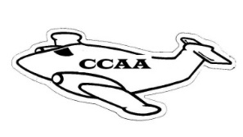
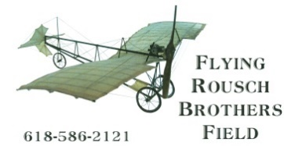
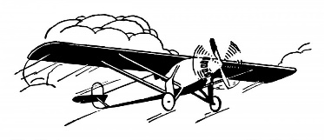

Crawford County Airport Authority
The Flying Rousch Brothers Field

Dave Shaw – Chair
Mark Hermann – Vice Chair
Cody Yager – Treasurer
Vicki May – Secretary
Becky Dart - Member
Cole Fiscus - Member
Max Smith - Member

PO Box 6, Robinson, Illinois 62454
Operator: Sky’s The Limit, Airport Fixed Base Operator
Howard Hunt, Sandy Staszak, Managers
Airport Telephone: (618) 586-2121
RCAA Airport Established December 30, 1959
AWOS Robinson Weather (618) 586-2772
Airport address: 10748 N 1650th St Palestine Illinois 62451
County Airport Established January 03, 2008---IDOT_D)A Organization #80533

DUNS:082090812--CAGE:7PLX5--MPIN:crawford1-- Tax Exempt Number:E9933-283-2 –EIN:26-1984176

Agenda for August 19, 2025 CCAA Board Meeting (6:00 P.M.)
Crawford County Airport Temporary Office

- Call to Order

- Roll Call of Members (Quorum Affirmed)
Dave Shaw Cody Yager
Vicky May Becky Dart
Cole Fiscus Mark Hermann
Max Smith

- Public Comment
  - Public Comment may be in person or in writing.
  - Public Comment is limited to five minutes per speaker

- Approval of prior meeting minutes (Ayes and Nayes)

- Department Reports

  - Treasurer’s Report (Roll Call Vote)
Dave Shaw Cody Yager
Vicky May Becky Dart
Cole Fiscus Mark Hermann
Max Smith
  - Treasurer – FY 2026 and 2027 Budget
  - Report from FBO/Airport Manager

- Old Business
  - Overview of current airport equipment status
    - Fuel Tanks/Truck
    - AWOS/Electrical system
  - Current building status
    - Terminal Building Construction
    - Replacement hangars - repairs
    - New Taxiway/PAPI
  - RSV Website/email
  - AWOS and RSV Starlink internet/cell service
  - RSV Bylaws and Ordinances
  - Contracts Committee
  - Open House/Grand Opening (Tentative date 10/24/25)
  - Airport Credit Card
  - Matt Wilson Lawsuit

- New Business
  - Board Member tenure review

- Member Non-Action Items for Discussion
  - TIP Meeting – a look ahead

- Call to Adjourn
Next regular scheduled meeting September 16, 2025, Airport Temporary Office

vlm 08/11/25

