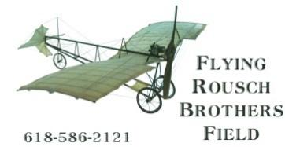
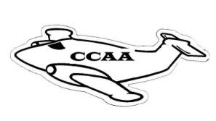
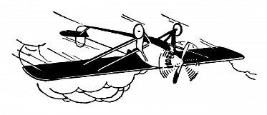

Crawford County Airport Authority
The Flying Rousch Brothers Field

Dave Shaw – Chair
Mark Hermann – Vice Chair
Vicki May – Secretary
Becky Dart - Member
Cole Fiscus - Member
Max Smith – Member
Tom Sparks – Member
--------------------------------------
Cody Yager – Treasurer

PO Box 6, Robinson, Illinois 62454
Operator: Sky’s The Limit, Airport Fixed Base Operator
Howard Hunt, Sandy Staszak, Managers
Airport Telephone: (618) 586-2121
RCAA Airport Established December 30, 1959
AWOS Robinson Weather (618) 586-2772
Airport address: 10748 N 1650th St Palestine Illinois 62451
County Airport Established January 03, 2008---IDOT_D)A Organization #80533

DUNS:082090812--CAGE:7PLX5--MPIN:crawford1-- Tax Exempt Number:E9933-283-2 –EIN:26-1984176

Agenda for April 21, 2026 CCAA Board Meeting (6:00 P.M.)
Crawford County Airport Office

- Call to Order

- Roll Call of Members (Quorum Affirmed)
Dave Shaw Tom Sparks
Vicki May Becky Dart
Cole Fiscus Mark Hermann
Max Smith

- Public Comment
  - Public Comment may be in person or in writing.
  - Public Comment is limited to five minutes per speaker

- Approval of prior meeting minutes (Ayes and Nayes)

- Department Reports

  - Treasurer’s Report (Roll Call Vote)
Dave Shaw Tom Sparks
Vicki May Becky Dart
Cole Fiscus Mark Hermann
Max Smith

  - Report from FBO/Airport Manager

- Old Business
  - Overview of current airport equipment status
    - Fuel Trucks
  - Current building status
    - Building Committee – new terminal
    - New Taxiway/PAPI
  - VOR building scrapping/demolition discussion
  - Open House/Fly in, May 2026
  - Surplus wooden building (former pilot lounge) – sealed bid notice and form
  - Electrical Vault Project
  - 14 CFR 13.2 Informal complaint letter from Richard Pur, FAA
  - Hire Tressler law firm to assist with FOIA, FAA, and State regulations
  - Section off the rental house property from airport property
  - US government excess property website
  - Commercial minimum standards revision to the By-laws
  - Matt Wilson Lawsuit

- Closed Session per 5 ILCS 120 Section 2(c)(11) if necessary
  - Review legal activity

- New Business
  - Indemnification of CCAA Members
  - New Registered Agent

- Member Non-Action Items for Discussion

- Call to Adjourn
Next regular scheduled meeting May 19, 2026, Airport Office

vlm 4/17/26

